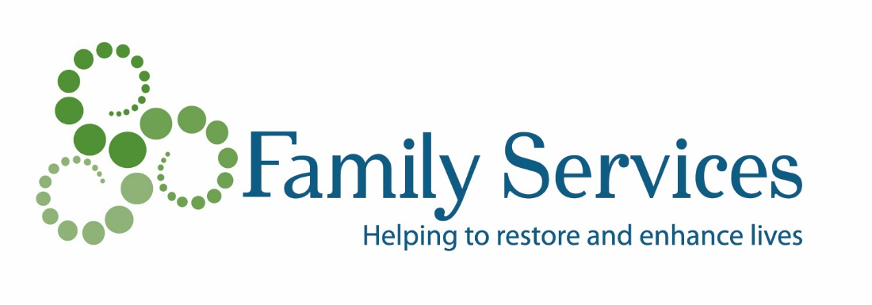
SAMPLE REQUEST LETTER FROM DONOR TO IRA ADMINISTRATOR FOR A QUALIFIED CHARITABLE DISTRIBUTION TO FAMILY SERVICES OF SOUTHERN WISCONSIN AND NORTHERN ILLINOIS, INC.

Date
Name of IRA Trustee/Administrator Address City, State Zip Code
Re: Qualified Charitable IRA Distribution to Family Services of Southern Wisconsin and Northern Illinois, Inc.
Dear Sir or Madam:
Please accept this letter as my request to make a direct charitable distribution (a “charitable IRA rollover”) in the amount of $ ____________ [any amount up to $100,000] from my Individual Retirement Account # ________________ [account number] as provided by Sec. 408(d)(8) of the Internal Revenue Code.
Distribution should be made payable to: Family Services of Southern Wisconsin and Northern Illinois, Inc, 416 College St Beloit, WI 53511
Family Service’s tax ID is: 39-0833966
My contact at Family Services is Pamela Prescott, Resource Development Director, who can be reached at (608-365-1244) or by email at pprescott@familyservices1.org.
In your transmittal to Family Services, please document my name and address as the donor of record in connection with this transfer. Please copy me on your transmittal. If you have any questions or need to contact me, I can be reached at ________________ [your telephone number].
Thank you for your assistance in this matter.
Sincerely,
[IRA Plan Owner/Donor]

